Signing TWC-VR PDF Forms Containing a Digital Signature Field
The latest PDF form additions to the VR Form List include a special form field for the user’s digital signature.
If you have not created a self-signing digital ID, you will be prompted to create a new digital ID before your signature is applied to the document.
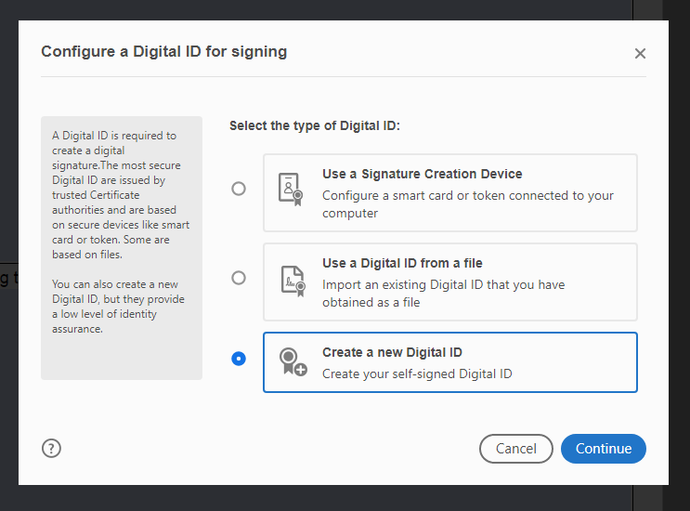
For instructions on creating a new self-signed digital ID, see Manage Digital IDs from Adobe.

Accessibility Workaround for Initial Digital Signature Creation for JAWS Screen Reader Users
The following instructions were provided by the TWC Accessibility team and describe how the initial digital signature creation process can be completed using the JAWS screen reader.
Q: Is the actual signature field in a PDF form accessible?
A: Yes, the user can navigate within a PDF to the signature field. With focus on that field, press Enter to activate. If your signature file has already been created, the signature appears in a dialog. Navigate to the Continue button and the signature appears on the PDF.
Q: Is there an issue with the screen reader being unable to recognize the process steps for creating the digital signature file?
A: Yes, there is an issue with the initial creation of a digital signature file, but there is a workaround; see below.

JAWS workaround for creating a digital signature with Acrobat Reader
When the signature dialog opens JAWS cannot access the controls in the signature, which makes it unusable.
- Control + K to open the preferences dialog.
- Use up and down arrows to select Signatures.
- Press Tab three times to navigate to the Identity and Trusted Certificates More button, then press Enter. Note: The button label does not read what it belongs to.
- Shift + Tab till you hear 'AVTableContainerView Add ID Button' and press Enter. This starts the process of adding a new signing certificate and dialog updates.
- Use Down arrow to select 'A new digital ID I want to create now', then Tab to next button. Dialog updates.
- Use Down arrow to select Windows Certificate store and select Next button. You do have an option, but this is the quickest without having to add a password.
- Fill out the following information, such as: name, Organization Unit, Organization Name, and Email. Leave the rest of the editable fields as is and continue to the Finish button. You now have a signing certificate and will not have to do this again.

