WORKFORCE DEVELOPMENT DIVISION
Workforce Programs
Technical Assistance Bulletin 303, Change 1
Keyword: General
Subject: LinkedIn Administrative Tools—Update
Date: February 14, 2024

This Technical Assistance (TA) Bulletin provides Local Workforce Development Boards (Boards) with centralized information regarding LinkedIn administrative tools, including the following:
- My Company page
- What We Do tab
- Recruiter platform
- Talent Insights platform
- Reports platform

Updates to this TA Bulletin include:
- the removal of the monthly reporting requirements; and
- information about monthly training sessions that are hosted by the Texas Workforce Commission (TWC).
Company Page
The My Company page (Figure 1), also known as a Career page, provides information for job seekers, employers, and community partners to learn about the Board’s purpose and services, information about upcoming events, and insights into the local job market.
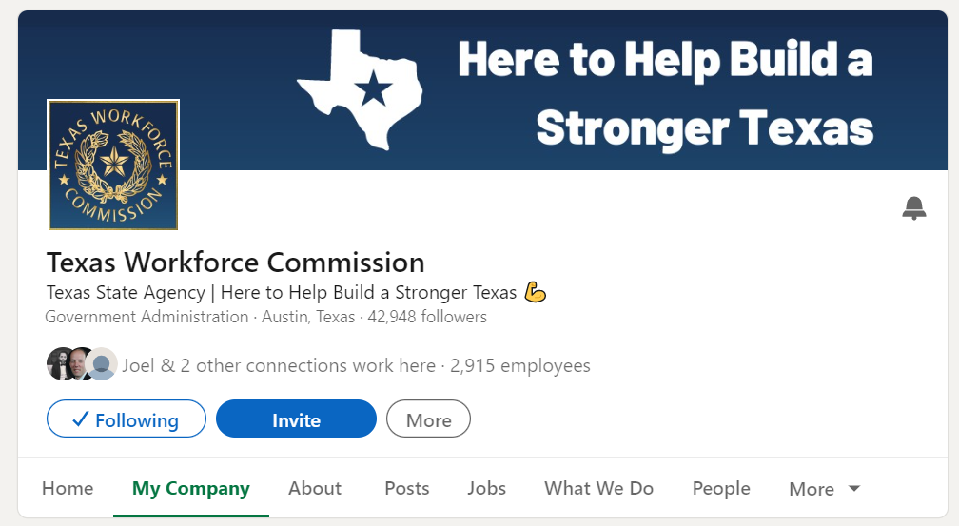
Figure 1: TWC’s Career Page
Related Resources
- Meet LinkedIn Career Pages—A desk aid that describes opportunities to highlight the Board’s services on the Home, About, Jobs, Life, People, and Insights subpages
- Career Page Essentials—A 30-minute webinar that describes how to set up a Career page
- LinkedIn Page Analytics—An article that describes the different types of analytics and how they may be used to gain insight into the performance of the Career page
- Visitor Analytics for Your LinkedIn Page—An article that describes the different types of visitor analytics and how they may be used to understand visitor traffic
What We Do Tab
The What We Do tab (Figure 2) allows the administrator to provide customized, targeted pages that publicize the Board’s services, workforce development programs, upcoming events, and more.
Related Resources
Administering LinkedIn Career Pages: What We Do Tab—A desk aid that describes the steps to create pages within the What We Do tab.
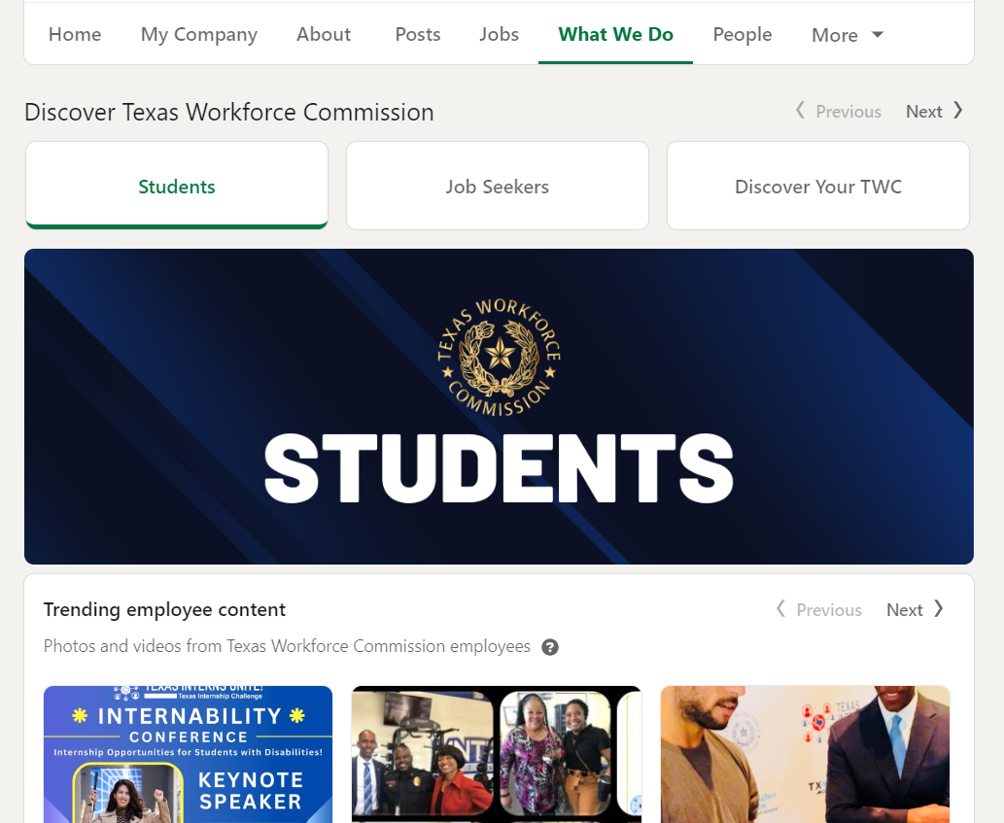
Figure 2: TWC’s What We Do Tab
Account Center and Recruiter
LinkedIn’s Account Center enables Recruiter administrators to give users the appropriate access.
The Recruiter platform (Figure 3) provides users with the ability to search the LinkedIn user database by skill, job title, location, remote work preference, and other categories. Users can send messages to job seekers to inform them about workforce development programs and potential job opportunities.
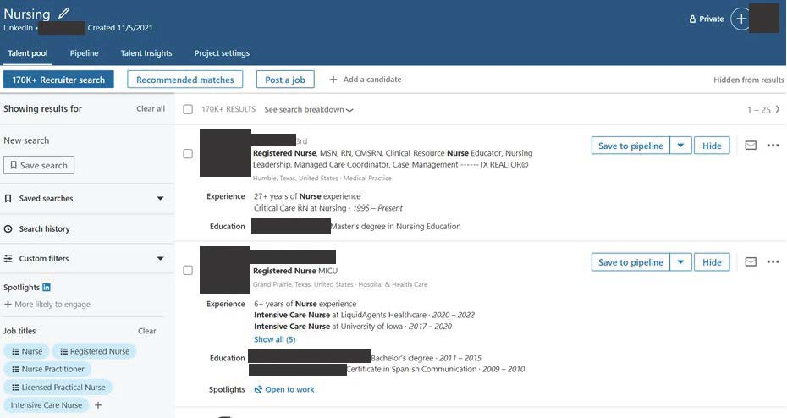
Figure 3: A view of the more than 170,000 users in Texas who have the job title of “nurse” using the Recruiter search function.
Related Resources
- Welcome to Account Center—A 17-minute video that provides an overview of the Account Center feature
- Explore LinkedIn Recruiter—A 20-minute tutorial that explains branding and how to create an efficient workflow in the Recruiter platform
- Meet LinkedIn’s New Recruiter and Jobs—A four-minute video that provides an overview of the Recruiter and Jobs features
- Explore Recruiter Projects—A six-minute tutorial on Recruiter projects and how to search for candidates and save searches for specific job requisitions or talent pipelines
- Post Your Jobs on LinkedIn—A 15-minute tutorial that explains how to post targeted jobs and efficiently review and manage applicants and recommended matches
- Reach Candidates with InMail—A one-minute video that explains how to directly reach candidates with InMail messages

Talent Insights
The Talent Insights platform (Figure 4) is used to generate real-time labor market supply and demand reports. Reports can be customized based on location, employer, industry, skill, education, and other filters. Boards can then navigate to the Recruiter platform to develop individualized talent pools and better understand employer workforce trends.
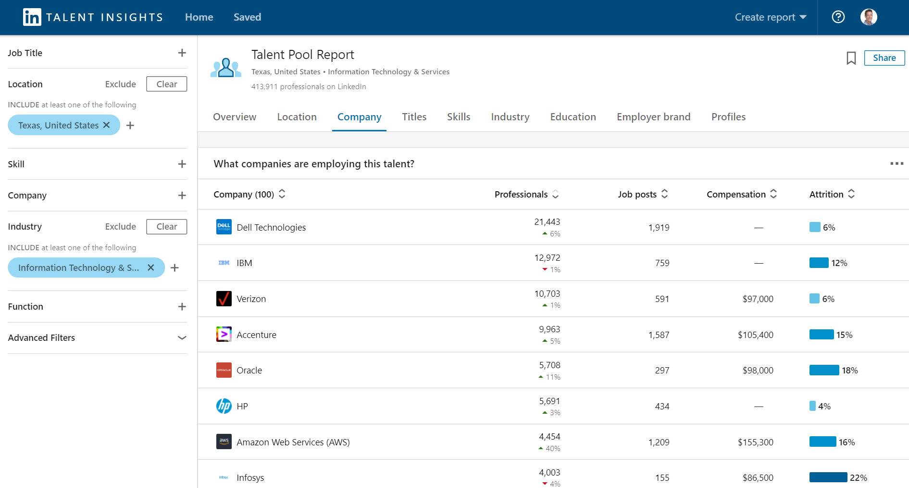
Figure 4: A Talent Pool Report that shows the 414,000 users who work in IT in Texas, their employer, and how many job postings each employer currently has.
Related Resources
- LinkedIn Talent Insights—A desk aid that explores Talent Insights basics
- Manage Your Talent Insights Licenses in Account Center—A desk aid that describes how to manage Talent Insights licenses
- Getting Started with LinkedIn Talent Insights for Staffing Partners—A 33-minute tutorial that explains how to generate reports to get data-driven insights into the local labor market
- LinkedIn Talent Insights Public Sector Playbook—A guide that provides resources to help plan and develop strategies for the efficient use of the Talent Insights platform
Reports
The LinkedIn Recruiter Reports platform provides metrics for all Board-licensed users by providing insight into performance, which can help improve overall usage strategies.

Related Resources
- Generate the Recruiter Usage Report—An article that provides the steps to generate a report that features usage metrics for all users under the Recruiter license
- Generate the Jobs Report in Recruiter and Recruiter Lite—An article that provides the steps to develop a Jobs report to assess job postings’ performance
- Interpret the Usage Report—An eight-minute tutorial that describes how to use the Recruiter Usage report to assess a Board’s overall performance metrics and recruiting efforts, as well as identify areas for improvement
- Interpret the Jobs Report—An eight-minute tutorial that describes how to use the Jobs report to determine whether job postings are targeting the right individuals
LinkedIn Assistance
Note: Use of a Virtual Private Network (VPN) will restrict access to LinkedIn administrative tools and online assistance.
TWC LinkedIn Tools Training
Board LinkedIn license holders are encouraged to attend TWC-hosted training. As trainings are developed and scheduled, notice of these trainings will be provided in the weekly WDD email and announced on Friday Board Calls.
Assistance with the Recruiter Platform
Questions regarding generating reports, creating projects, and other related topics may be answered through the Recruiter Help prompt. For assistance:
- log in as a recruiter; and
- click the question mark (?) icon in the upper right-hand corner.
Figure 5: The question mark icon is in the upper right-hand corner.
On the Help page, select:
- “Launch Tutorials” or “Learning Center” for Recruiter training videos and materials;
- “Chat with support” for immediate assistance;
- “Open Help in a new tab” for topic-specific articles relating to Recruiter and other platforms and services; or
- “Create a support ticket” to report an issue with LinkedIn (for example, Projects, How to Post a Job, Edit a Job, and Candidate Search).
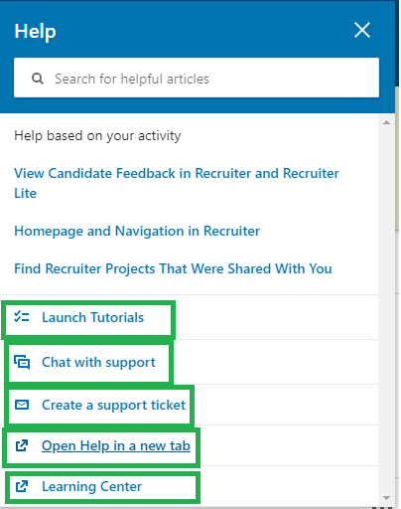
Figure 6: The Help prompt with options on ways to receive assistance regarding the Recruiter platform
Assistance with the Talent Insights Platform
Questions regarding Talent Pool Reports and other related topics may be answered through the Talent Insights Help prompt. For assistance:
- log into LinkedIn Talent Insights; and
- click on the question mark (?) icon in the upper right-hand corner.
Figure 7: The question mark icon is in the upper right-hand corner.
On the Help page, select:
- “Create a support ticket” to report an issue with Talent Insights (for example, Reports or Interpreting Reports);
- “Open Help in a new tab” for topic-specific articles relating to Talent Insights and other platforms and services; or
- “Open Learning Center in new tab” for Talent Insights training videos and materials.
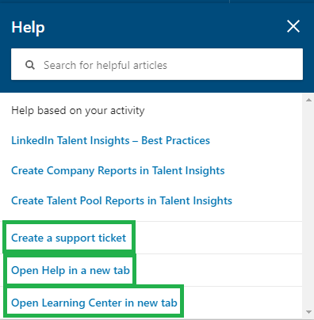
Figure 8: The Help prompt with options on ways to receive assistance regarding the Talent Insights platform
License Assistance
For questions regarding Recruiter and Talent Insights license assignments, contact the Workforce Automation support desk at wfsupportdesk@twc.texas.gov.
Local Job Orders Assistance
For questions regarding local job orders, contact WIOA Technical Assistance at wioatechnicalassistance@twc.texas.gov.
Please distribute this information to the appropriate staff. Send inquiries regarding this TA Bulletin to wfpolicy.clarifications@twc.texas.gov.

